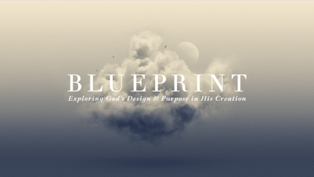

The Pattern & Purpose of Rest
Genesis 1:31–2:3

At the completion of creation, God establishes an essential rhythm for human flourishing and the expansion of his good purposes in the world—today we examine the pattern & purpose of rest!

1:31 God’s Perfect COMPLETION

2:1–2 God’s PATTERN of Rest

2:3 God’s PURPOSE in Rest

