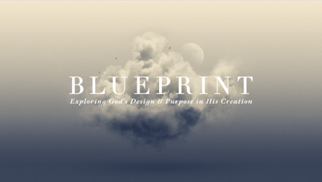

Created with Dignity
Psalm 8

This week we turn to Psalm 8 to see how the God whose glory fills the heavens has crowned humans with dignity & honor—giving our lives profound value & purpose under his majestic name!

1 The MAJESTY of God’s Name

2–4 The Overwhelming GLORY of the Creator!

5 The DIGNITY of Humanity

6–8 The ROLE of Humanity in Creation

9 The MAJESTY of God’s Name

