Cayucos Community Church - Sermon Notes: 1-25-2026 Pastor Bret Martin

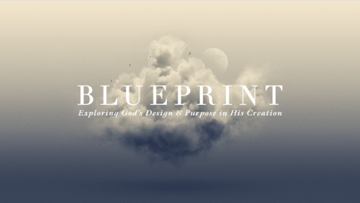

From Creation to Creator
Psalm 19:1–6

The created world unmistakably proclaims the glory of its Creator! This week—as we further explore a flourishing life in God’s design—Psalm 19 invites us to consider our response to God’s divine communication through creation.

- God’s Voice is UNDENIABLE (vv. 1–3)

- God’s Voice Demands a RESPONSE (v. 4)

- God’s Voice Reaches ALL (vv. 5–6)

